Contact Annemarie Roketenetz, Director, Communications & Public Relations,
aroketenetz@ncra.org or 703/969-6363 (text or call)

Local Contact name and contact information

MEDIA ADVISORY
NCRA’s 2026 Court Reporting & Captioning Week, Feb. 7-14, is the perfect time to thank your captioner and showcase their work

RESTON, Va.- DATE - The 2026 Court Reporting & Captioning Week, hosted by the National Court Reporters Association Feb. 7-14, offers the perfect opportunity to showcase the skills of your station’s captioners and to share with your viewers more about the unique careers stenographic court reporting and captioning offer. NCRA is the country’s leading organization representing stenographic court reporters, captioners, and legal videographers.

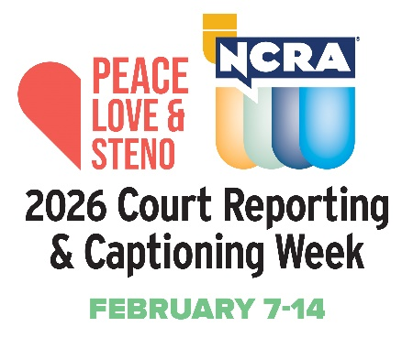
Help showcase this unique profession and increase the public’s awareness of what stenographic captioners do such as helping to make better the lives of millions of Americans who are deaf and hard of hearing by providing captioning in real time, not just for newscasts, but for television shows, live sporting and theater events, church services, movie houses, and many other venues.

Why not invite your captioner to appear on one of your network’s morning programs or local news broadcasts to demonstrate how captioning works, share their stories about how they learned about the profession, and the many opportunities their chosen career path has provided them, as well as to just shine a light on the important work they do.

Included below are some fun and interesting facts about the stenographic captioning and court reporting professions:

- Capturing the record of important proceedings dates back to the fourth century B.C.

- The ampersand (&) is one of the earliest forms of shorthand still in use.

- There are official court reporters who are employees of the court; freelance deposition reporters; broadcast captioners; and CART captioners (Communications Access Realtime Translation) — often employed in classroom settings to assist students who are deaf and hard of hearing.

- In emergency situations, broadcast captioners can provide vital information to 50 million Americans who are deaf and hard of hearing.

- Court reporters and captioners use cutting-edge technology to bring the spoken word accurately to text in real time.

- Learning the skills of a stenographic captioner does not require a four-year degree. In fact, most graduate from their programs in less than two years and are well on their way to earning good salaries nearly immediately without the burden of the costs of a four-year degree.

- There is a steady need for more stenographic court reporters and captioners to fill positions across the nation and abroad.

Court reporters and captioners rely on the latest in technology to use stenographic machines to capture the spoken word and translate it into written text in real time. These professionals work both in and out of the courtroom recording legal cases and depositions, providing live captioning of events, and assisting members of the deaf and hard-of-hearing communities with gaining access to information, entertainment, educational opportunities, and more.

If you’re looking for a career that is on the cutting edge of technology, offers the opportunity for work at home or abroad, like to write, enjoy helping others, and are fast with your fingers, then the fields of court reporting and captioning are careers you should explore at NCRA/discoversteno.org.

The NCRA A to Z® Intro to Steno Machine Shorthand program, a free online six-week introductory course, lets participants see if a career in court reporting or captioning would be a good choice for them. The program is an introduction to stenographic theory and provides participants with the opportunity to learn the basics of writing on a steno machine.

To arrange an interview with a working court reporter, captioner, legal videographer, or a current court reporting student, or to learn more about the lucrative and flexible court reporting or captioning professions and the many job opportunities currently available, contact pr@ncra.org.

About NCRA
The National Court Reporters Association (NCRA) has been internationally recognized for promoting excellence among those who capture and convert the spoken word to text for more than 125 years. NCRA is committed to supporting its more than 10,000 members in achieving the highest level of professional expertise with educational opportunities and industry-recognized court reporting, educator, and videographer certification programs. NCRA impacts legislative issues and the global marketplace through its actively involved membership.

The U.S. Bureau of Labor Statistics reports that the court reporting field is expected to be one of the fastest areas of projected employment growth across all occupations. Career information about the court reporting profession — one of the leading career options that do not require a traditional four-year degree — can be found at NCRA DiscoverSteno.org.

