Contact Annemarie Roketenetz, Director, Communications & Public Relations,
aroketenetz@ncra.org or 703/969-6363 (text or call)

Name of your organization
Address including city and state
Contact information including full name, phone, email

2026 Court Reporting & Captioning Week celebrates Peace, Love & Steno

Feb. 7-14 will showcase the amazing skills of stenographic court reporters and captioners

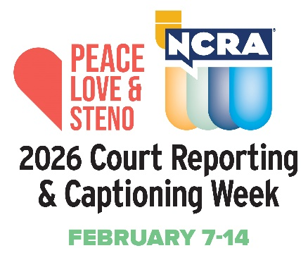
RESTON, Va., DATE - The nationwide 2026 Court Reporting & Captioning Week, sponsored by the National Court Reporters Association (NCRA), will be celebrated by court reporters, captioners, legal videographers, and others involved in the legal community. Feb.7-14 will mark the event’s 14th year of observance and is being celebrated with the theme: Peace, Love & Steno. NCRA is the country’s leading organization representing stenographic court reporters, captioners, and legal videographers.

“We are asking the media to help us showcase the stenographic court reporting and captioning professions this year by spotlighting local court reporters and captioners through interviews and sharing with viewers how they capture the spoken word and preserve it in text,” said full name and title of person being quoted.

“The demand for stenographic court reporters and captioners is at an all-time high right now. It can take on average as little as two years to complete a stenographic court reporting program, allowing those who choose this career path the ability for nearly instant employment without the debt of a four-year college degree,” he/she added.

Here are some facts you probably didn’t know…

- A four-year college degree is not required to become a stenographic court reporter or captioner, providing graduates of a specialized program with the opportunity to enter the workforce more quickly and with less debt.
- There is a huge need for professionals to fill stenographic court reporting and captioning jobs around the nation and abroad.
- A career in stenographic court reporting or captioning offers good pay, unlimited opportunities to travel at home and abroad, a variety of venues in which to work, and very often, a front row seat to history.
- Stenographic captioners do wonderful work to help better the lives of millions of Americans who are deaf or hard of hearing by providing captioning in real time for live sporting and theater events, church services, movie houses, many other venues, and newscasts like yours!

Here are a few more fun and interesting facts about the court reporting and captioning professions:

- Capturing the record of important proceedings dates to the fourth century B.C.
- The ampersand (&) is one of the earliest forms of shorthand still in use today.
- There are official court reporters who are employees of the court, freelance deposition reporters who work directly with attorneys, broadcast captioners, and CART captioners (Communication Access Realtime Translation) — often employed in classroom settings to assist students who are deaf or hard of hearing.
- In emergencies, stenographic broadcast captioners can provide vital information to 48 million Americans who are deaf or hard of hearing.
- Stenographic court reporters and captioners use cutting-edge technology to bring the spoken word accurately to text in real time.
- The need for professionals in the stenographic court reporting and captioning fields is at a steady demand so employment upon graduation is nearly instant.
- Annual salaries of court reporters and captioners can reach upwards of $80,000 or more.

Court reporters and captioners rely on the latest in technology to use stenographic machines to capture the spoken word and translate it into written text in real time. These professionals work both in and out of the courtroom recording legal cases and depositions, providing live captioning of events, and assisting members of the deaf and hard-of-hearing communities with gaining access to information, entertainment, educational opportunities, and more.

If you’re looking for a career that is on the cutting edge of technology, offers the opportunity for work at home or abroad, like to write, enjoy helping others, and are fast with your fingers, then the fields of court reporting and captioning are careers you can explore at NCRA/discoversteno.org.

The NCRA A to Z® Intro to Steno Machine Shorthand program, a free online six-week introductory course, lets participants see if a career in court reporting or captioning would be a good choice for them. The program is an introduction to stenographic theory and provides participants with the opportunity to learn the basics of writing on a steno machine.

To arrange an interview with a working court reporter, captioner, legal videographer, or a current court reporting student, or to learn more about the lucrative and flexible court reporting or captioning professions and the many job opportunities currently available, contact pr@ncra.org.

About NCRA
The National Court Reporters Association (NCRA) has been internationally recognized for promoting excellence among those who capture and convert the spoken word to text for more than 125 years. NCRA is committed to supporting its more than 10,000 members in achieving the highest level of professional expertise with educational opportunities and industry-recognized court reporting, educator, and videographer certification programs. NCRA impacts legislative issues and the global marketplace through its actively involved membership.

The U.S. Bureau of Labor Statistics reports that the court reporting field is expected to be one of the fastest areas of projected employment growth across all occupations. Career information about the court reporting profession — one of the leading career options that do not require a traditional four-year degree — can be found at NCRA DiscoverSteno.org.

