Contact Annemarie Roketenetz, Director, Communications & Public Relations,
aroketenetz@ncra.org or 703/969-6363 (text or call)

Name of Local Contact
Email/Phone

(Name of School) to celebrate Peace, Love & Steno
during 2026 National Court Reporting & Captioning Week

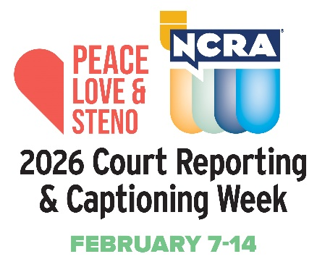
YOUR CITY, YOUR STATE, DATE, 2025 — The National Court Reporters Association (NCRA), the country’s leading organization representing stenographic court reporters, captioners, and legal videographers, has announced that (SCHOOL NAME highlight with link to your website) in (City, State) is promoting the career opportunities in stenographic court reporting and captioning by participating in the 2026 National Court Reporting & Captioning Week, Feb. 7-14.

The weeklong event, themed Peace, Love & Steno, will bring court reporters, captioners, court reporting firms, schools, and others in the legal industry together to help highlight the many aspects that make a career in this field so attractive, including a quicker entrance into the workforce since no four-year degree is required, good salaries, flexibility in schedules, interesting venues, and nearly immediate employment after graduations due to the demand for more to enter the profession. The week also serves to remind the public and those in the legal field why the record produced by a human stenographic court reporter or captioner is considered the gold standard of the industry.

(NAME OF SCHOOL), a premier court reporting education program, is celebrating the national effort by [highlight activities, cite examples. It may be as simple as “encouraging its student population to get involved with Court Reporting & Captioning Week by engaging in a grassroots effort to promote the profession and educate local communities about the value stenographic skills bring to today’s marketplace.”]

“Provide a quote about the importance of this awareness week and the importance of this profession,” said (full name and title).

“We believe that court reporting and captioning is worthy of national recognition, and we are proud to take part in this national initiative,” said (last name of school official quoted earlier).

The 2026 event marks the 14th year NCRA has hosted the celebration.

“There’s nothing more fun than promoting our profession by introducing what we do to potential students and the public, and Court Reporting & Captioning Week affords us the opportunity to shine as an organization nationally as we do this,” said NCRA President Cindy Isaacsen, RPR, an official court reporter from Shawnee, Kan.

“Help us spread the word about this lucrative and flexible career option that could be the right fit for those high school grads not interested in college, degree holders who found their original career choice was not what they expected it to be, career changes, military spouses, and those transitioning from military service,” Isaacsen added.

Court reporters and captioners rely on the latest in technology to use stenographic machines to capture the spoken word and translate it into written text in real time. These professionals work both in and out of the courtroom recording legal cases and depositions, providing live captioning of events, and assisting members of the deaf and hard-of-hearing communities with gaining access to information, entertainment, educational opportunities, and more.

If you’re looking for a career that is on the cutting-edge of technology, offers the opportunity for work at home or abroad, like to write, enjoy helping others, and are fast with your fingers, then the fields of court reporting and captioning are careers you can explore at NCRA/discoversteno.org.

The NCRA A to Z® Intro to Steno Machine Shorthand program, a free online six-week introductory course, lets participants see if a career in court reporting or captioning would be a good choice for them. The program is an introduction to stenographic theory and provides participants with the opportunity to learn the basics of writing on a steno machine.

To arrange an interview with a working court reporter, captioner, legal videographer, or a current court reporting student, or to learn more about the lucrative and flexible court reporting or captioning professions and the many job opportunities currently available, contact pr@ncra.org.

About NCRA
The National Court Reporters Association (NCRA) has been internationally recognized for promoting excellence among those who capture and convert the spoken word to text for more than 125 years. NCRA is committed to supporting its more than 10,000 members in achieving the highest level of professional expertise with educational opportunities and industry-recognized court reporting, educator, and videographer certification programs. NCRA impacts legislative issues and the global marketplace through its actively involved membership.

The U.S. Bureau of Labor Statistics reports that the court reporting field is expected to be one of the fastest areas of projected employment growth across all occupations. Career information about the court reporting profession — one of the leading career options that do not require a traditional four-year degree — can be found at NCRA DiscoverSteno.org.

