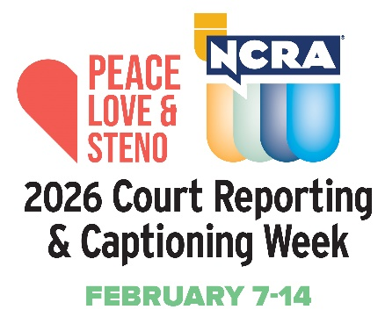
Dear (Name of student),

The 14th national Court Reporting & Captioning Week, hosted by the National Court Reporters Association (NCRA), is coming up and we need your help promoting this fantastic event and this exciting profession. The awareness week, happening Feb. 7-14, 2026, highlights the nationwide contributions of stenographic court reporters, CART captioners, and broadcast captioners to society. The week also showcases the many well-paying and flexible career opportunities available in the court reporting and captioning fields. This year NCRA is celebrating with the theme: Peace, Love & Steno.

Please check out the resources page NCRA has created to help you with promoting the event. Here you will find an array of downloadable and customizable materials to help you celebrate. Resources include press release templates, logos, posters, flyers, and much more.

During the weeklong event NCRA members, state affiliates, court reporting schools, students, vendors, and others affiliated with the legal world come together to promote the stenographic court reporting and captioning professions and highlight why stenographic court reporting and captioning is the gold standard for making the most accurate record.

Check the resource page regularly for even more promotional materials as they become available. We’re all really excited about this year’s national Court Reporting & Captioning Week, and with your support, we know this event will be a great success. Please feel free to email me with any questions that you might have. And be sure to share how you celebrate with NCRA by sending stories and pictures to pr@ncra.org.

Sincerely,

(Name of program director)

