Contact Annemarie Roketenetz, Director, Communications & Public Relations,
aroketenetz@ncra.org or 703/969-6363 (text or call)

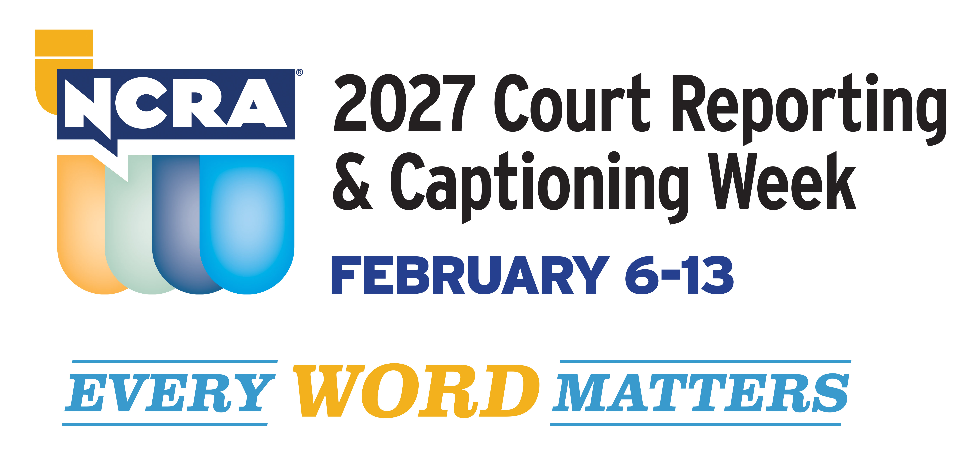

STATE Gov. XXX recognizes
2027 NCRA Court Reporting & Captioning Week Feb. 6-13

RESTON, Va., Feb. XX, 2027 — The National Court Reporters Association (NCRA), the country’s leading organization representing stenographic court reporters, captioners, and legal videographers, wishes to thank Gov. XXX for issuing an official proclamation declaring Feb. 6-13 2027 Court Reporting & Captioning Week in that state. The proclamation was secured by members of the STATE ASSOCIAITION WITH LINK TO WEBSITE.

“The 2027 Court Reporting & Captioning Week theme, Every Word Matters, reminds us that whether capturing and preserving the official record or providing captioning to those who need access to the spoken word, what we do matters in ways most don’t realize,” said NCRA President Cathy Penniston, MA, RPR, CRI, a court reporting instructor and broadcast captioner from Waukee, Iowa.

“I encourage everyone to celebrate our skills this week and throughout the year and bring awareness to the important role we play every day in the lives of others,” she added.

NCRA members, state affiliates, court reporting schools, students, vendors, and others affiliated with the legal world will use the week to highlight why stenographic court reporting and captioning is the gold standard for making the most accurate record when it comes to capturing the spoken word. Members of NCRA are available nationwide to talk with media outlets and share why they love their jobs and more about this career choice that does not require a four-year degree or the hefty tuition costs typically associated with it.

Learn more about:

- How to explore a career in stenographic court reporting and captioning that can take as little as two years of skills training.
- NCRA’s A to Z® Intro to Steno Machine Shorthand program, a free six-week online or asynchronous program that provides the perfect opportunity for potential students to learn the alphabet in steno, write on a real machine, and decide if pursuing an education in court reporting or captioning is the right choice.
- Why stenography is such a special skill, the machine and technology today’s court reporters and captioners rely on to do their jobs, earning potential, job flexibility, and the many venues where court reporters and captioners can find themselves working.
- Why there is an increasing demand for more reporters and captioners to meet the growing number of employment opportunities available nationwide and abroad
- Why artificial intelligence and digital recording modes cannot and will not replace the human court reporter when it comes to capturing the most accurate record both in and out of the courtroom.
- NCRA’s and the National Court Reporters Foundation (NCRF)’s continued commitment to offer more than $65,000 in scholarships and grants to students and new professionals annually to provide financial assistance.

Court reporters and captioners rely on the latest in technology to use stenographic machines to capture the spoken word and translate it into written text in real time. These professionals work both in and out of the courtroom recording legal cases and depositions, providing live captioning of events, and assisting members of the deaf and hard-of-hearing communities with gaining access to information, entertainment, educational opportunities, and more.

If you’re looking for a career that is on the cutting-edge of technology, offers the opportunity for work at home or abroad, like to write, enjoy helping others, and are fast with your fingers, then the fields of court reporting and captioning are careers you can explore at NCRA/discoversteno.org.
The NCRA A to Z® Intro to Steno Machine Shorthand program, a free online six-week introductory course, lets participants see if a career in court reporting or captioning would be a good choice for them. The program is an introduction to stenographic theory and provides participants with the opportunity to learn the basics of writing on a steno machine.

About NCRA
The National Court Reporters Association (NCRA) has been internationally recognized for promoting excellence among those who capture and convert the spoken word to text for more than 125 years. NCRA is committed to supporting its more than 10,000 members in achieving the highest level of professional expertise with educational opportunities and industry-recognized court reporting, educator, and videographer certification programs. NCRA impacts legislative issues and the global marketplace through its actively involved membership.

The U.S. Bureau of Labor Statistics reports that the court reporting field is expected to be one of the fastest areas of projected employment growth across all occupations. Career information about the court reporting profession — one of the leading career options that do not require a traditional four-year degree — can be found at NCRA DiscoverSteno.org.

