Contact Annemarie Roketenetz, Director, Communications & Public Relations,
aroketenetz@ncra.org or 703/969-6363 (text or call)

MEDIA ADVISORY

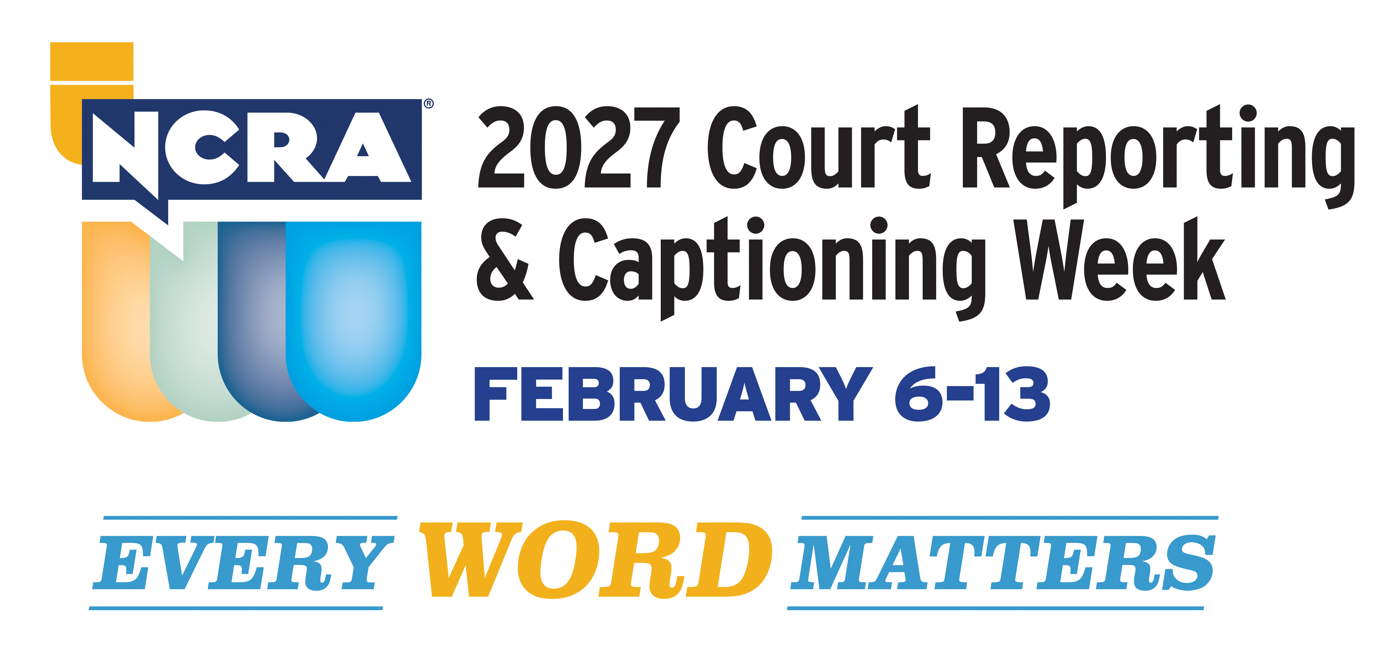

Recognize the good work your captioner does during
NCRA’s 2027 Court Reporting & Captioning Week, Feb. 6-13

RESTON, Va.- XXX, 2027 - The 2027 Court Reporting & Captioning Week, hosted by the National Court Reporters Association Feb. 6-13, offers the perfect opportunity to showcase the skills of your station’s captioners and to share with your viewers more about the unique careers stenographic court reporting and captioning offer. NCRA is the country’s leading organization representing stenographic court reporters, captioners, and legal videographers.
Help us showcase this unique profession and increase the public’s awareness of what stenographic captioners do to better the lives of millions of Americans who are deaf and hard of hearing by providing captioning in real time for newscasts, television shows, live sporting and theater events, church services, movie houses, and many other venues.
The week marks the perfect time to invite your captioner to appear on one of your network’s morning programs or local news broadcasts to demonstrate how captioning works, share their stories about how they learned of the profession and the many opportunities their chosen career path has provided them, as well as to shine a light on the important work they do.

Included below are some fun and interesting facts about the stenographic captioning and court reporting professions:

- Capturing the record of important proceedings dates back to the fourth century B.C.

- The ampersand (&) is one of the earliest shorthand symbols still in use.

- Official court reporters are employees of the court; freelance court reporters work within the legal system to take depositions; broadcast captioners provide access to the spoken word in a number of venues to the deaf and hard-of-hearing communities; and CART captioners (Communications Access Realtime Translation) are often employed in classroom settings to assist students who are deaf and hard of hearing.

- In emergency situations, broadcast captioners can provide vital information to 50 million Americans who are deaf and hard of hearing.

- Court reporters and captioners use cutting-edge technology to bring the spoken word accurately to text in real time.

- Learning the skills of a stenographic captioner does not require a four-year degree. In fact, most graduate from their programs in less than two years and are well on their way to earning good salaries almost immediately without the burden of the costs of a four-year degree.

- There is a steady and immediate need for more stenographic court reporters and captioners to fill positions across the nation and abroad.

Court reporters and captioners rely on the latest in technology to use stenographic machines to capture the spoken word and translate it into written text in real time. These professionals work both in and out of the courtroom recording legal cases and depositions, providing live captioning of events, and assisting members of the deaf and hard-of-hearing communities with gaining access to information, entertainment, educational opportunities, and more.

Consider a career in court reporting or captioning. The NCRA A to Z® Intro to Steno Machine Shorthand program is a free online six-week introductory course that lets participants see if a career in court reporting or captioning would be a good choice for them. The program is an introduction to stenographic theory, offered online or as an asynchronous program, and provides participants with the opportunity to learn the basics of writing on a steno machine. Learn more at NCRA DiscoverSteno.org.

To arrange an interview with a working court reporter, captioner, legal videographer, or a current court reporting student, or to learn more about the lucrative and flexible court reporting or captioning professions and the many job opportunities currently available, contact pr@ncra.org.

About NCRA
The National Court Reporters Association (NCRA) has been internationally recognized for promoting excellence among those who capture and convert the spoken word to text for more than 125 years. NCRA is committed to supporting its more than 10,000 members in achieving the highest level of professional expertise with educational opportunities and industry-recognized court reporting, educator, and videographer certification programs.

The U.S. Bureau of Labor Statistics reports that the court reporting field is expected to be one of the fastest areas of projected employment growth across all occupations.

