Contact Annemarie Roketenetz, Director, Communications & Public Relations,
aroketenetz@ncra.org or 703/969-6363 (text or call)

Local Contact name and contact information

MEDIA ADVISORY
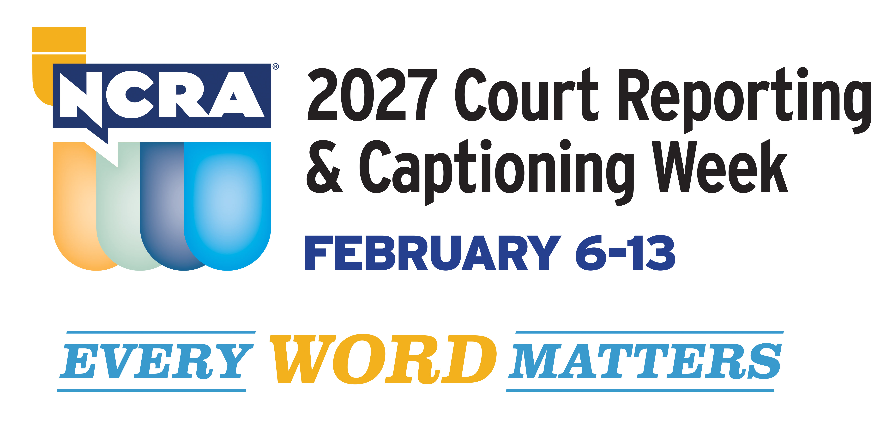
RESTON, Va.- DATE – Every Word Matters is the theme for the 2027 Court Reporting & Captioning Week, being hosted Feb. 6-13 by the National Court Reporters Association, the country’s leading organization representing stenographic court reporters, captioners, and legal videographers.

The weeklong event shines a light on the unique skills stenographic court reporters and captioners employ in their daily jobs. It is also the perfect opportunity for broadcast media outlets to introduce their viewers to their own broadcast captioners and let them showcase their skills, as well as share more about the endless possibilities this profession has to offer.

Let’s increase the public’s awareness of what stenographic captioners do such as helping to better the lives of millions of Americans who are deaf and hard of hearing by providing captioning in real time, not just for newscasts, but for television shows, live sporting and theater events, church services, movie houses, and many other venues.

Take this opportunity to share with your viewers more about:

- How to explore a career in stenographic court reporting and captioning that can take as little as two years of skills training.
- NCRA’s A to Z® Intro to Steno Machine Shorthand program, a free six-week online or asynchronous program that provides the perfect opportunity for potential students to learn the alphabet in steno, write on a real machine, and decide if pursuing an education in court reporting or captioning is the right choice.
- Why stenography is such a special skill, the machine and technology today’s court reporters and captioners rely on to do their jobs, earning potential, job flexibility, and the many venues court reporters and captioners can find themselves working in.
- Why there is an increasing demand for more reporters and captioners to meet the growing number of employment opportunities available nationwide and abroad
- Why artificial intelligence and digital recording modes cannot and will not replace the human court reporter when it comes to capturing the most accurate record both in and out of the courtroom.
- NCRA’s and the National Court Reporters Foundation’s continued commitment to offer more than $65,000 in scholarships and grants to students and new professionals annually to provide financial assistance.

Just for fun, we’ve also included some interesting facts about the stenographic captioning and court reporting professions:

- Capturing the record of important proceedings dates back to the fourth century B.C.
- The ampersand (&) is one of the earliest forms of shorthand still in use.
- There are official court reporters who are employees of the court; freelance deposition reporters; broadcast captioners; and CART captioners (Communications Access Realtime Translation) are often employed in classroom settings to assist students who are deaf and hard of hearing.
- In emergency situations, broadcast captioners can provide vital information to 50 million Americans who are deaf and hard of hearing.
- Court reporters and captioners use cutting-edge technology to bring the spoken word accurately to text in real time.
- Learning the skills of a stenographic captioner does not require a four-year degree. In fact, most graduate from their programs in less than two years and are well on their way to earning good salaries almost immediately without the burden of the costs of a four-year degree.
- There is a steady need for more stenographic court reporters and captioners to fill positions across the nation and abroad.

Court reporters and captioners rely on the latest in technology to use stenographic machines to capture the spoken word and translate it into written text in real time. These professionals work both in and out of the courtroom recording legal cases and depositions, providing live captioning of events, and assisting members of the deaf and hard-of-hearing communities with gaining access to information, entertainment, educational opportunities, and more.

If you’re looking for a career that is on the cutting edge of technology, offers the opportunity for work at home or abroad, like to write, enjoy helping others, and are fast with your fingers, then the fields of court reporting and captioning are careers you should explore at NCRA/discoversteno.org.

To arrange an interview with a working court reporter, captioner, legal videographer, or a current court reporting student, or to learn more about the lucrative and flexible court reporting or captioning professions and the many job opportunities currently available, contact pr@ncra.org.

About NCRA
The National Court Reporters Association (NCRA) has been internationally recognized for promoting excellence among those who capture and convert the spoken word to text for more than 125 years. NCRA is committed to supporting its more than 10,000 members in achieving the highest level of professional expertise with educational opportunities and industry-recognized court reporting, educator, and videographer certification programs. NCRA impacts legislative issues and the global marketplace through its actively involved membership.

The U.S. Bureau of Labor Statistics reports that the court reporting field is expected to be one of the fastest areas of projected employment growth across all occupations. Career information about the court reporting profession — one of the leading career options that do not require a traditional four-year degree — can be found at NCRA DiscoverSteno.org.

