See below for sample proclamation:
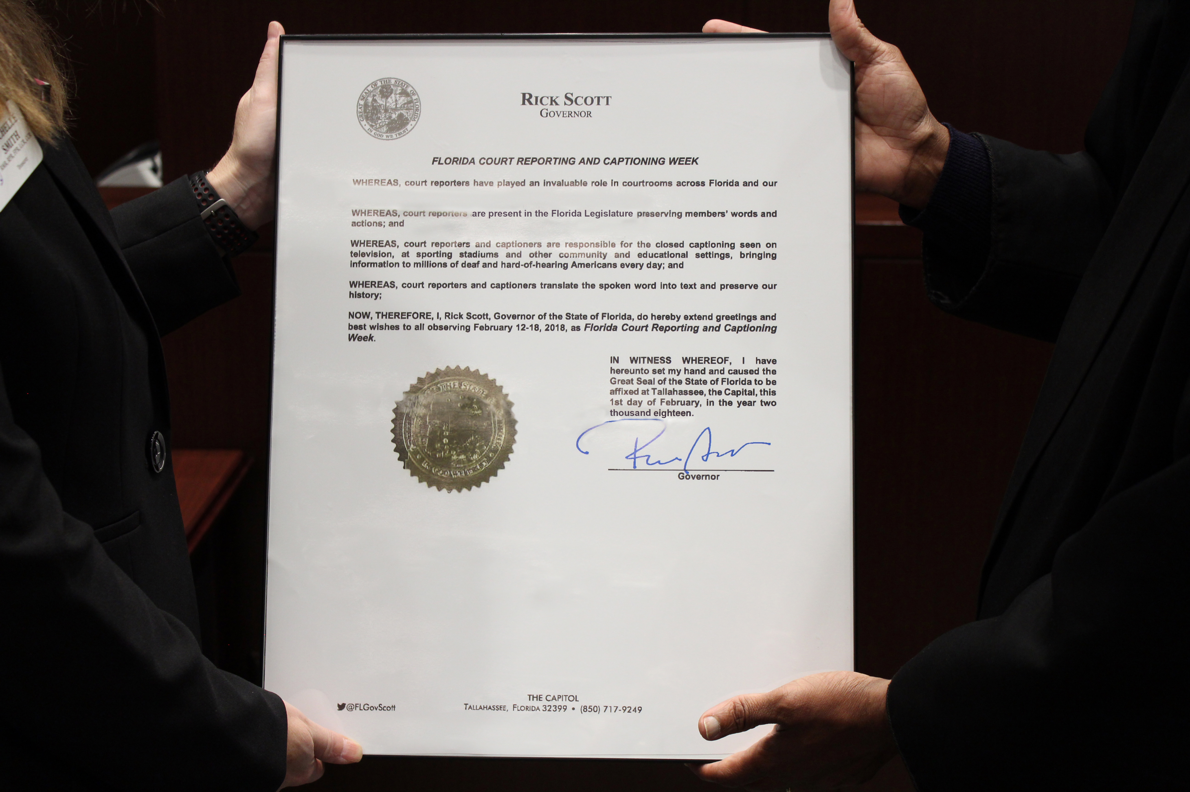

All highlighted text can be customized.
Please print on your letterhead as per sample above.

Name of official
Title of official

Name of Court Reporters Association

WHEREAS, court reporters and captioners are present in the NAME OF STATE Legislature preserving members’ words and actions; and

WHEREAS, court reporters and captioners are responsible for the closed captioning seen on television, at sporting stadiums, and other community and educational settings, bringing information to millions of deaf and hard-of-hearing Americans every day; and

WHEREAS: court reporters and captioners translate the spoken word into text and preserve our history; NOW, THEREFORE, I NAME OF OFFICIAL, TITLE OF OFFICAL, do hereby extend greetings and best wishes to all observing February 9-16, 2019, as NAME OF STATE Court Reporting & Captioning Week.

IN WITNESS WHEREOF, I have hereunto set my hand and caused the Great Seal of the NAME OF STATE to be affixed at CITY NAME OF STATE, the Capital, this DATE OF SIGNATURE, in the year two thousand nineteen.

________________________________________________
Governor

AFFIX STATE SEAL

